**DAILY ONLINE ACTIVITIES SUMMARY**

|  |  |  |  |  |  |  |  |  |
| --- | --- | --- | --- | --- | --- | --- | --- | --- |
| **Date:** | **19TH may,2020** | | | | | **Name:** | **Prathusha K A** | |
| **Sem & Sec** | **4th sem &b section** | | | | | **USN:** | **4AL18CS061** | |
| **Online Test Summary** | | | | | | | | |
| **Subject** | | **Design and analysis of algorithm** | | | | | | |
| **Max. Marks** | | **30** | | **Score** | | | **14** | |
| **Certification Course Summary** | | | | | | | | |
| **Course** | **Programming for everybody (getting started with python)** | | | | | | | |
| **Certificate Provider** | | | **Coursera** | | **Duration** | | | **7 weeks** |
| **Coding Challenges** | | | | | | | | |
| **Problem Statement:** A user will input two strings, and we find if one of the strings is a sub sequence of the other. Program prints “yes” if either the first string is a sub sequence of the second string or the second string is a sub sequence of the first string.Assume that, the length of the first string is smaller than or equal to the length of the second string | | | | | | | | |
| **Status:done** | | | | | | | | |
| **Uploaded the report in Github** | | | | | **yes** | | | |
| **If yes Repository name** | | | | | **https://github.com/prathu47/lockdown-coding** | | | |
| **Uploaded the report in slack** | | | | | **yes** | | | |

Online Test Details: (Attach the snapshot and briefly write the report for the same)

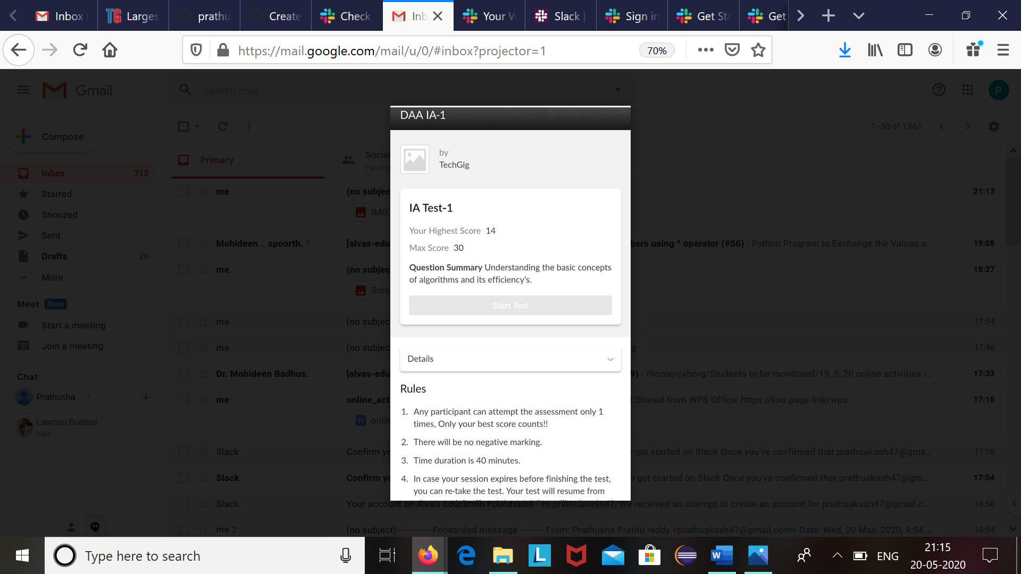

Design and analysis of algorithm internals was conducted today. 18CS42 test was scheduled from 9:15 am to 9:55 am. The time was not sufficient to answer all the questions. There were 20 questions of 1 marks and 5 questions of 2 marks respectively.

Certification Course Details: (Attach the snapshot and briefly write the report for the same)

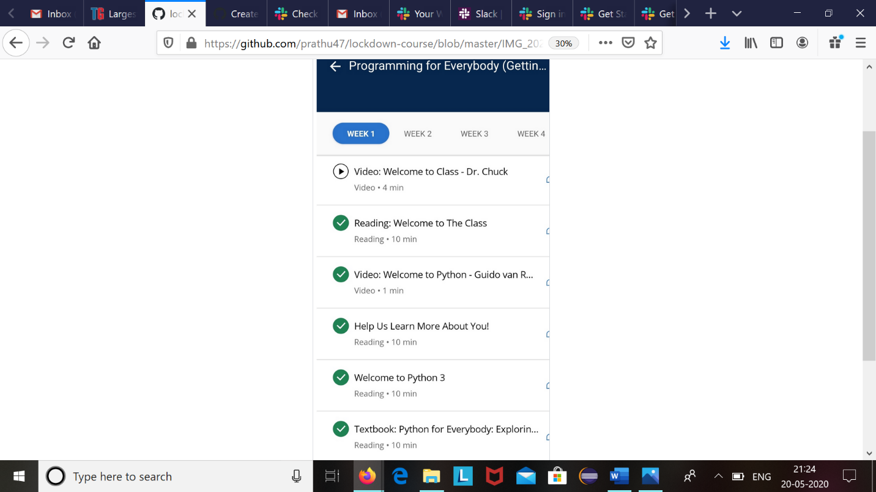

The course I have chosen during the lckdown period is programming for everybody. Since I had previously knew few topics about python iam continuing this course.Since python is gaining a lot of interest in coding platform I have preferred to choose this course.

Coding Challenges Details: (Attach the snapshot and briefly write the report for the same)

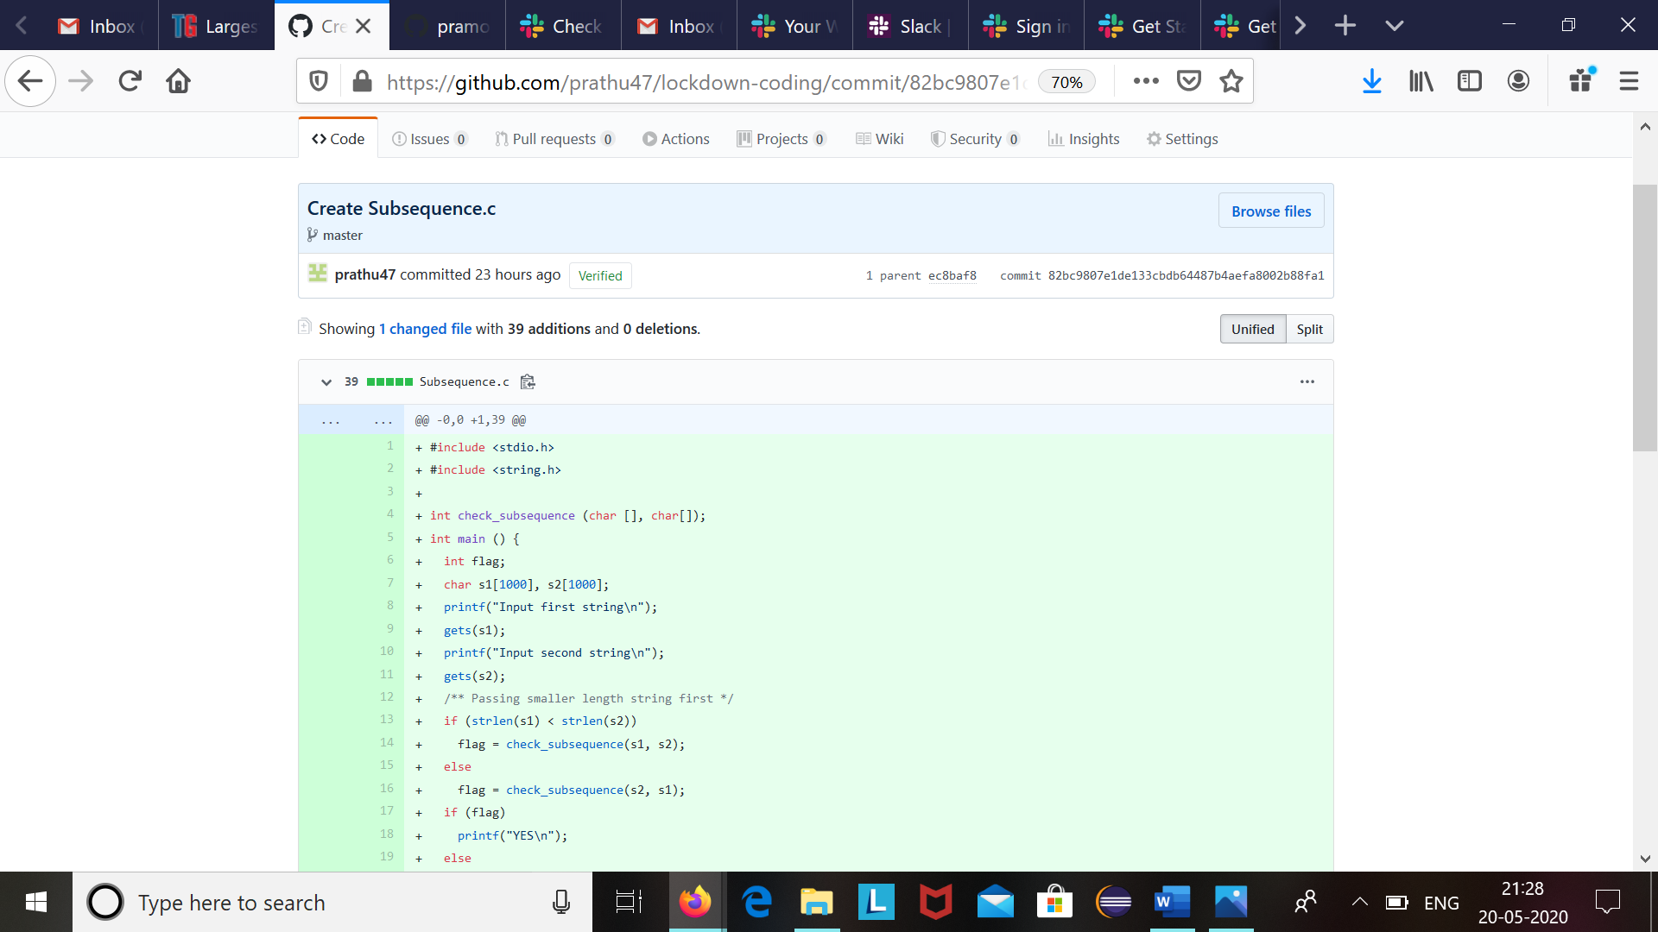

Code:The above snapshot is the code which I have uploaded in my github repository.